HaptiGlow-Helping Users Position their Hands for Better Mid-Air Gestures and Ultrasound Haptic Feedback

【Main Content】：

We present HaptiGlow, a technique that combines ultrasound haptics with peripheral visual feedback to help users ﬁnd where to place their hand for improved mid-air interaction.

【HaptiGlow】：

Our goal is to use this feedback to guide users to better hand positions before interaction, which improves input sensing and tactile quality. Once in a better position, the input should seamlessly transition to its intended use (for example, grabbing a virtual object or manipulating a virtual control).

**Feedback Design：**

1. **Visual feedback**
2. **Haptic feedback:**

We did this by creating an ultrasound haptic cone, whose base was centred in the sweet spot (Fig. 3). The orientation of the cone was changed so that it was always perpendicular to the palm of the hand. This preserved the spatial relationship between hand position and the feedback, whilst ensuring it could be perceived regardless of hand orientation (Fig. 4). The conical shape of the feedback meant that users perceived its circular cross-section on their hand, increasing in diameter as they approached the sweet spot, as in Fig. 3.

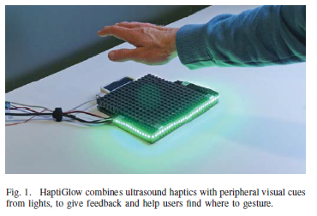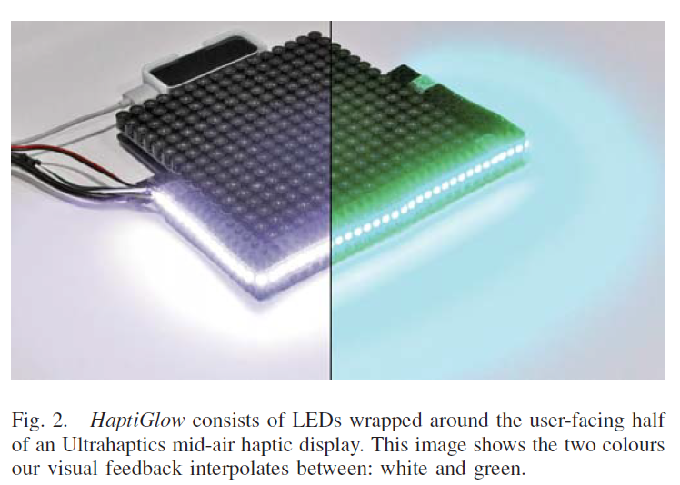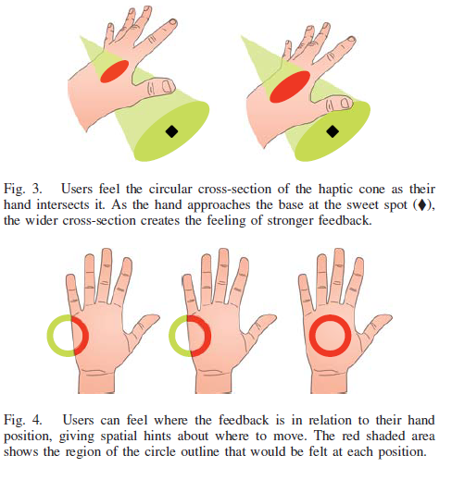

【Experiments】：

We use a design with three types of feedback:

1. LIGHTS
2. HAPTICS
3. HAPTICS + LIGHTS

Results:

Our results show that HAPTICS and LIGHTS had unique strengths that, when combined, led to an effective multimodal feedback design. Haptic feedback was good at conveying the position of the target point in the horizontal plane (Fig. 6). This was not surprising, because the haptic feedback gives spatial information directly to the hand; users knew they were in the right area when the feedback was centred on their palm and many of our participants said this in the post-study survey.

In contrast to the HAPTICS condition, visual feedback under the LIGHTS condition results in good accuracy in the z-axis, but not in the xy plane (Figure 6). We wanted HAPTICS to provide better performance because it provided spatial information, but we were surprised that visual feedback successfully helped users place their hands at the correct height above the device.

The HAPTICS + LIGHTS condition results in the best accuracy and fastest time.

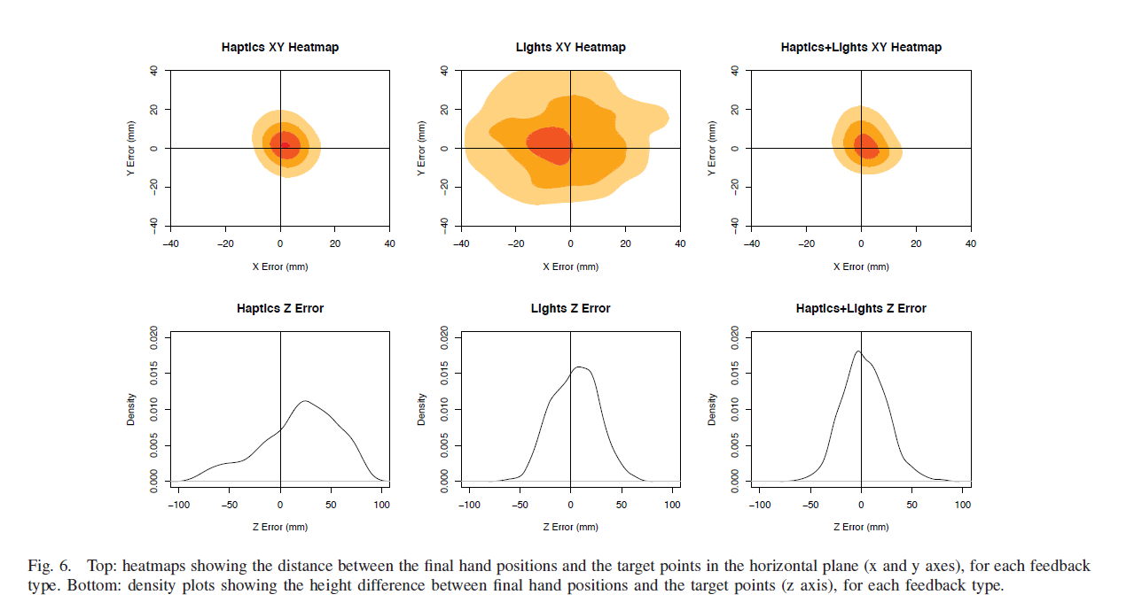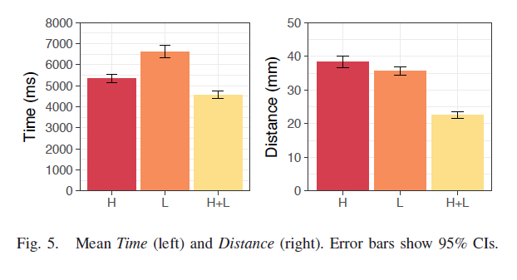

【Conclusion】：

We studied its ability to guide users to aim to targets to better understand how to use feedback to help them find the right hand posture before starting an interaction. The combination of light and air haptics is more effective than the individual methods. Users use them in different ways, taking advantage of each method to minimize time and improve hand positioning accuracy. This also shows the benefits of adding low-cost peripheral vision to ultrasound haptic devices, as our simple visual feedback is sufficient to improve interactivity.